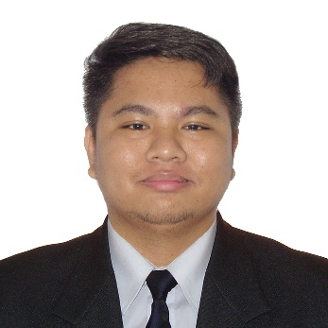**JUSTINE RAINIEL A. RAMOS**

+63 945 713 3297

[justinerainielramos@gmail.com](mailto:justinerainielramos@gmail.com)

Poblacion 3, Taal, Batangas 4208

**Skills**

**Languages:** C#, C++, PHP, jQuery Javascript

**Database:** MySQL/PHPMyAdmin, Microsoft SQL Server

**Framework:** .NET (MVC), Bootstrap 4/5

**Libraries:** ChartJS

**Developer Tools:** Git, Github, Azure DevOps

**Work Experience**

**ARC System Solutions Co.**

Lipa City, Batangas

**Software Developer, January 2024 - March 2024**

**Technologies used:** C#, .NET MVC, WinForms .NET, MS SQL, Bootstrap, CSS, ChartJS

* Primarily responsible on maintaining bug fixing productions issues.
* Responsible for implementing new features and optimization on existing features.
* Perform QA Test to minimize issues before deployment to Production.
* Generate weekly report the web application’s status and client’s concern.

**Assistant Web Developer, June 2023 - January 2024**

**Technologies used:** C#, .NET MVC, MS SQL, Bootstrap, CSS, ChartJS

* Provide assistance to the Lead Developer, providing insights, suggestions and optimizations on the project.
* Primarily responsible for implementing the project’s cart and discount feature.
* Responsible on integration of third party API libraries
* Provide database management using Microsoft SQL Server
* Generate weekly report on the project’s progress.

**Projects**

**Thesis & Capstone Project Manager (**https://github.com/Jake-Hero/thesis-project-manager**)**

**Technologies used:** PHP, MySQL/PHPMyAdmin, Bootstrap, jQuery, Github

* Responsible for leading the project’s development.
* Primarily responsible for implementing the UI/UX design into front-end.
* Primarily responsible for integrating APIs which involves reading a PDF into the website.
* Develop a web application in Vanilla PHP, where Lycean Students can collaborate, upload their documents and interact with each other about their thesis & capstone research.

**Educational Attainment**

**Bachelor of Science in Information Technology - Major in Multimedia Technologies**

Lyceum of the Philippines University - Batangas

*2019 – 2023*

**Technical-Vocational-Livelihood - ICTCP**

Lyceum of the Philippines University - Senior High School Batangas

*2017 – 2019*

**Seminars**

**iSITE Webinar - Machine Learning**

Lyceum of the Philippines University Batangas / iSITE Inc. - Zoom Meeting *September 10, 2022*

**iSITE Webinar - Industrial Revolution 4.0**

Lyceum of the Philippines University Batangas / iSITE Inc. - Zoom Meeting

*September 3, 2022*